|  |
| --- |
| Software Engineering of Distributed Systems Kungl Tekniska Högskolan |
| Problem and Solution of Goldy |
| Seminar Paper of Distributed Systems |

|  |
| --- |
| Shanbo Li  2007-10-16 |

Problem and Solution of Goldy

Shanbo Li 840810-A478 [shanboli@Gmail.com](mailto:shanboli@Gmail.com)

This is a paper for a seminar of distributed systems. There are four parts in this paper. Firstly this paper shows a distributed game named Goldy and implemented with Erlang. Then it will describe the problem of Goldy. After that it will give some solution of the problem. At last an outline of implement will be illustrated.

# Goldy: a distributed game

Goldy is a distributed game which is implemented by Erlang with a very simple structure. Each player in Goldy will start the game and announce her position and also announce the positions of a set of gold nuggets. Each player can then start to move, trying to collect as many nuggets as possible. There are three types of spot on the user’s window. And spot with red shows the operator’s current position, greed spots are other players’ position, yellow spots mean that they are gold nuggets. *Figure 1* shows a screenshot of Goldy.

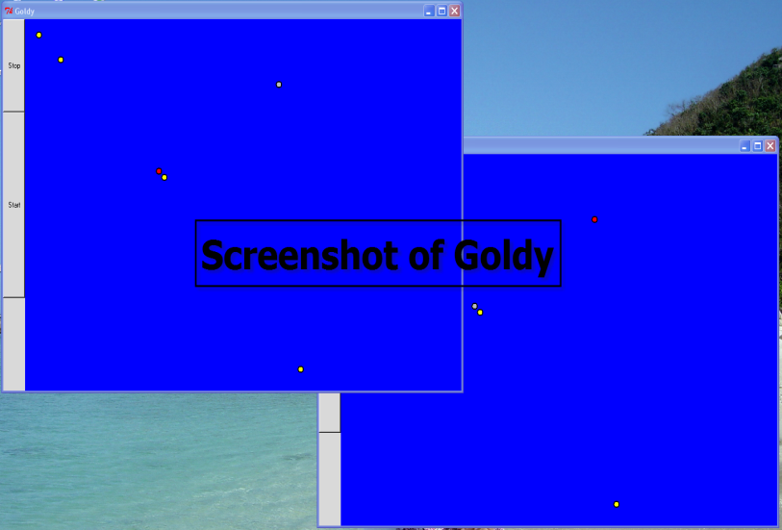

Figure screenshot of Goldy

# The problem of Goldy

It is fun to collect the gold nuggets. But some problem occurred while we played the game. What you see is not what you really got. Or one play can see that he eats the gold, but another guy announced it is himself who really gets the gold nugget. It seems that at a certain moment different players have different screens. It should not be like